**Topic: finance case study**

**Main: Revenue Performance of Japan in 2018 & Predictions in 2019**

**Group members: ZHU Huilei & SYBOU Kaoutar**

**Introductions:**

**Blue Corporation is a brand of ready-to-wear clothing for the whole family. It is a simplified joint stock company created in 2003. Blue Corporation is a brand created for children. It is clothing in which little ones should feel comfortable, ready to face the intrepid days of every child. In 2010, our brand expanded to adults and offered men's and women's clothing in addition to birth, baby and children's sizes. In 2012, we created in Japan .** **We have captured the entire Japanese market, and our sales in Japan are doing well.**

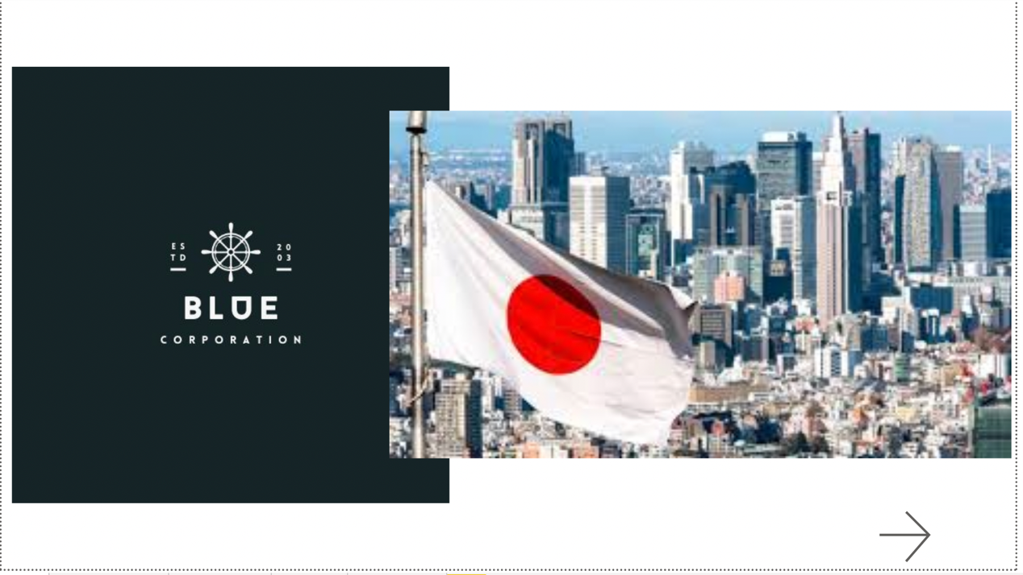

**Japan sales’s life cycle from 2012-2018**

**Japan’s revenue performance in 2018**

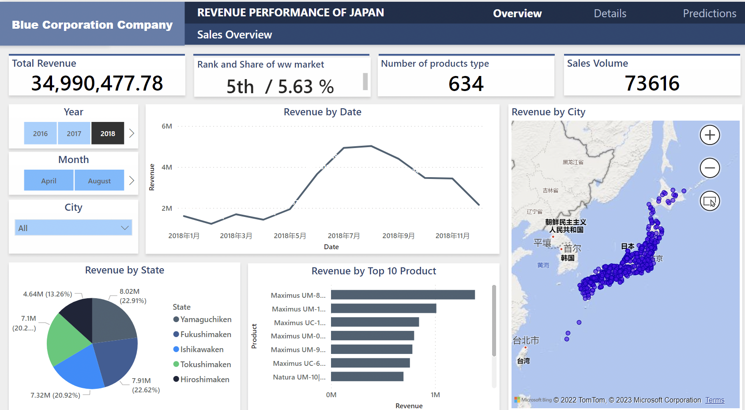

**Japan’s products and manufactueres in 2018**

**Worldwide predictions**

